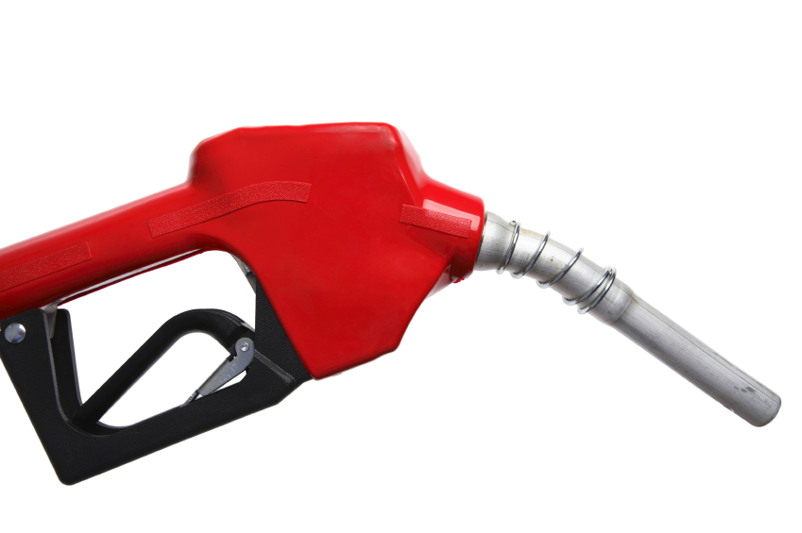

We’re running on empty! Time to stop at the gas station and fill up the tank! Use the prices for different fuel types at various fuel brands/dealers (bottom of the page) in order to complete the requirements (listed on the next page).

Petro Canada
Regular $1.25
Plus $1.33
Supreme $1.45
Diesel $1.12

Esso
Regular $1.27
Plus $1.37
Supreme $1.47
Diesel $1.15

Sunoco
Regular $1.25
Plus $1.35
Supreme $1.45
Diesel $1.14

Shell
Regular $1.22
Plus $1.30
Supreme $1.38
Diesel $1.10

Husky
Regular $1.22
Plus $1.31
Supreme $1.40
Diesel $1.08

Canadian Tire
Regular $1.24
Plus $1.34
Supreme $1.47
Diesel $1.11

*Note: all prices are in dollars ($) per litre (L)

- Open Microsoft Excel and save the new file to your M: drive as “Your Name_Fuel Prices”. Ensure you save in .xlsx format.

- Enter the fuel prices into an Excel spreadsheet so that you have a data table comparing the fuel prices at each gas station within the various fuel categories (e.g. Regular, Plus, etc.).
  - List the fuel brands/companies (Canadian Tire, Esso, etc.) vertically and the fuel types (Regular, Plus, etc.) horizontally across the top of your data table. In other words, the fuel companies will be listed down one column and the fuel types will be listed across one row (and the various fuel prices will be entered into the cells where the two intersect).

- Create an appropriate title for your data table.

- Create subtitles and formulas that identify and calculate the average, highest and lowest prices for each fuel type.

- Sort the fuel brands in ascending order (from lowest to highest) based on the price of their Regular-grade fuel. (hint: use the Custom Sort feature)

- Format the spreadsheet (using a proper formula) so that any Regular-grade fuel price below the Regular category average shows up in green coloured font and any above the average shows up in red coloured font.

- Use an “IF” statement to create a new column that labels Diesel prices below $1.11/L as a “GREAT DEAL!”.

- Create an appropriate title for your data table and customize to add visual impact (merge & centre, modify font size & colour, etc.)

- Use the Icon Sets feature to tag or mark Supreme fuel prices as follows:
  - any prices above or equal to $1.47/L with a red “x”
  - any prices less than $1.47 but equal to or greater than $1.42 with a yellow exclamation point (!)
  - any prices less than $1.42 with a green checkmark ()

- Use the data in the spreadsheet to create 2 sensible or applicable graphs/charts. Place the first graph/chart in Sheet2 and the second in Sheet3. Ensure your graphs are complete and can be understood without needing explanation or access to the data, by including things such as (if necessary):
  - an appropriate title
  - applicable axis titles
  - complete and properly labelled legend
  - data labels
  - gridlines and/or trendlines
  - altered or customized aesthetics (fills, effects, WordArt, etc.)

- Give each sheet tab an appropriate name or label and tab colour.

- Resave the document to your M: drive and then drag & drop a copy to the appropriate HandIn folder.

